Getting Started with Jenkins

Enter the URL for access:

<http://LocalHost:Port/jenkins>

For the first time you will see a screen asking for a password. You can find the password in the path mentioned on the same screen

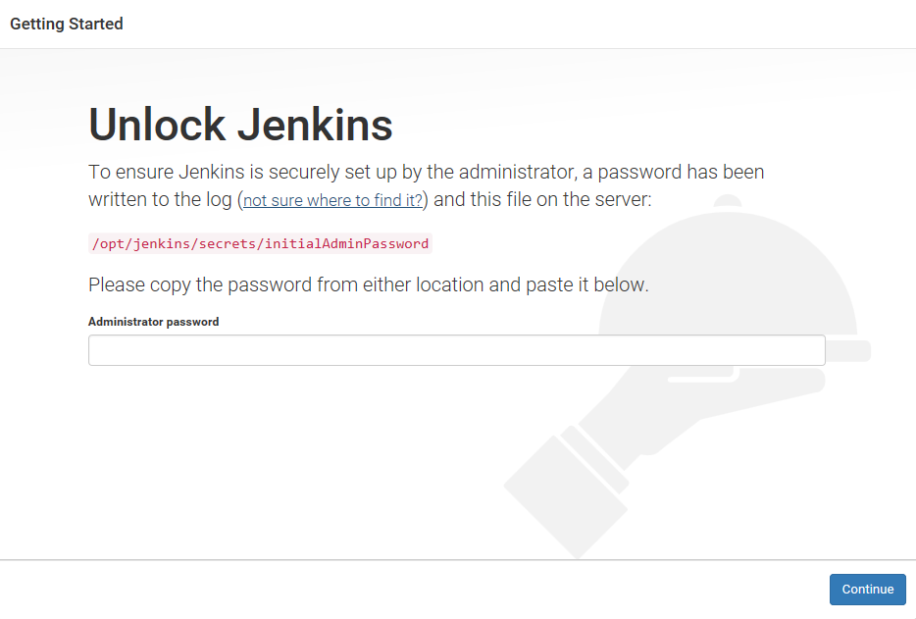

Enter the Administrator password and Press Continue

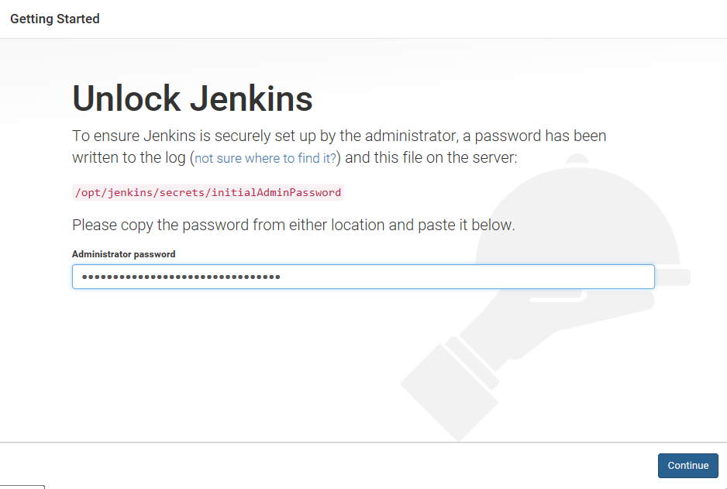

Select Install Suggested Plugins option

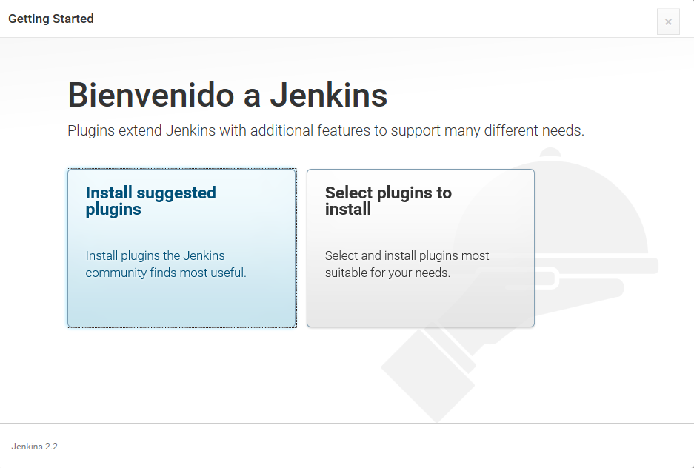

Create a First Admin User and Password

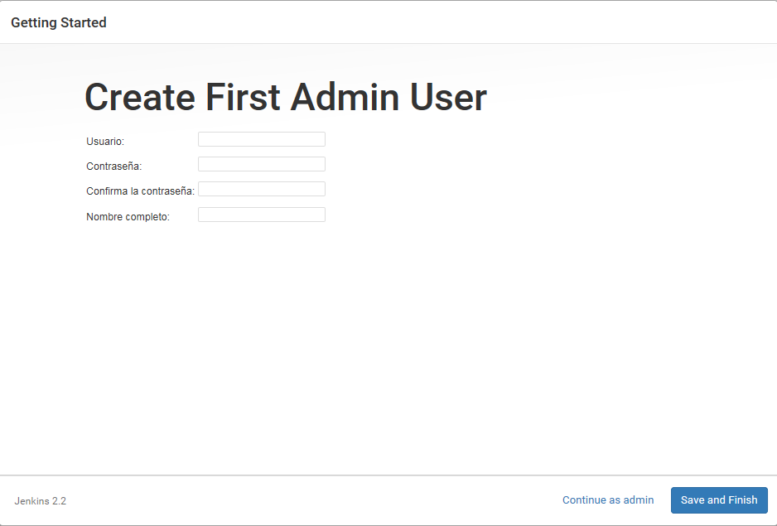

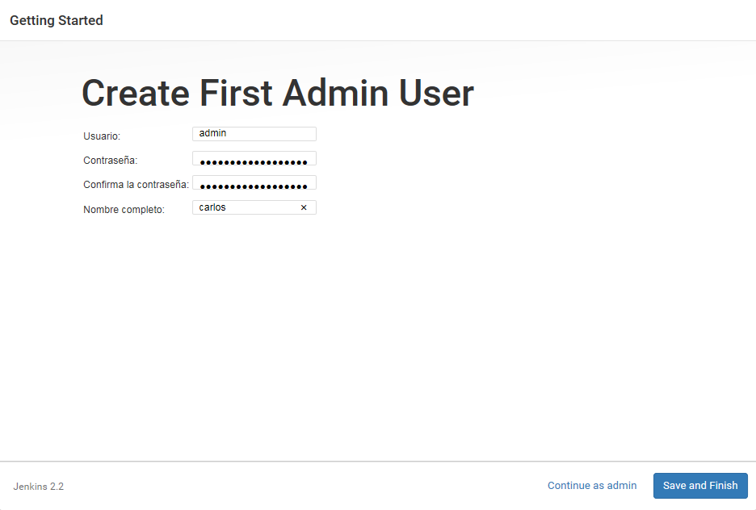

If you press Save and Finish the user created will be stored but if you decided to click on Continue as admin, you will have to use same password as before and the user name will be “admin”

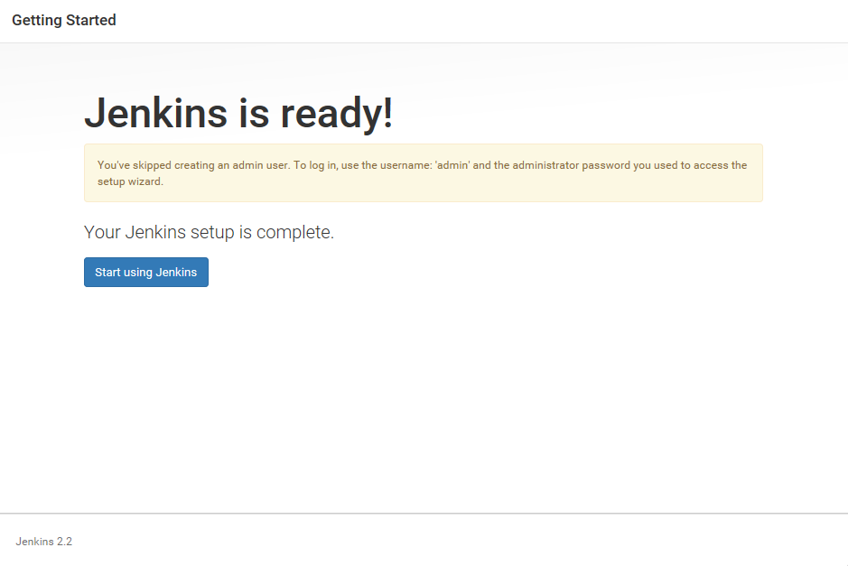

Click on Start using Jenkins Button and you will be on Welcome Screen Menu

